Discussion date: 10/21 9:33-10:19

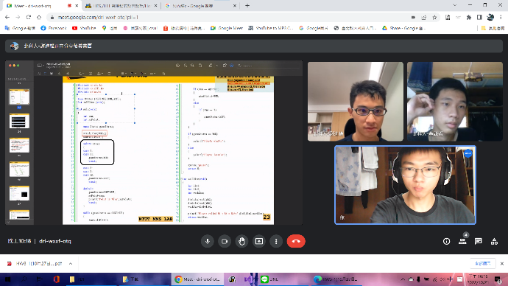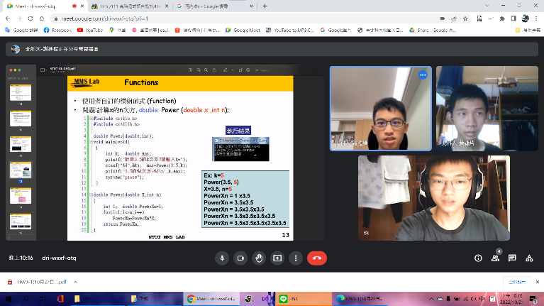

P12

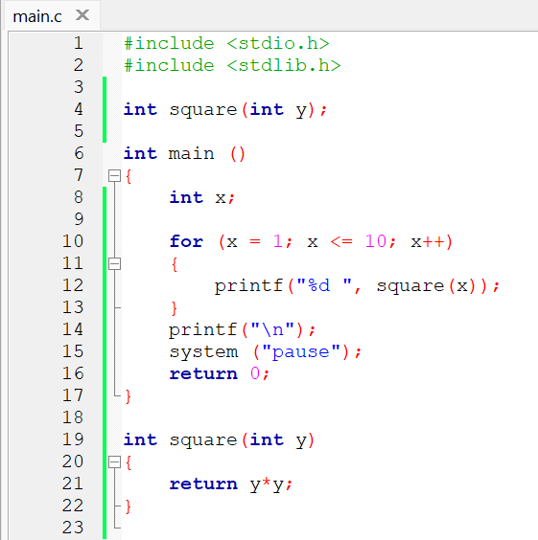

P13

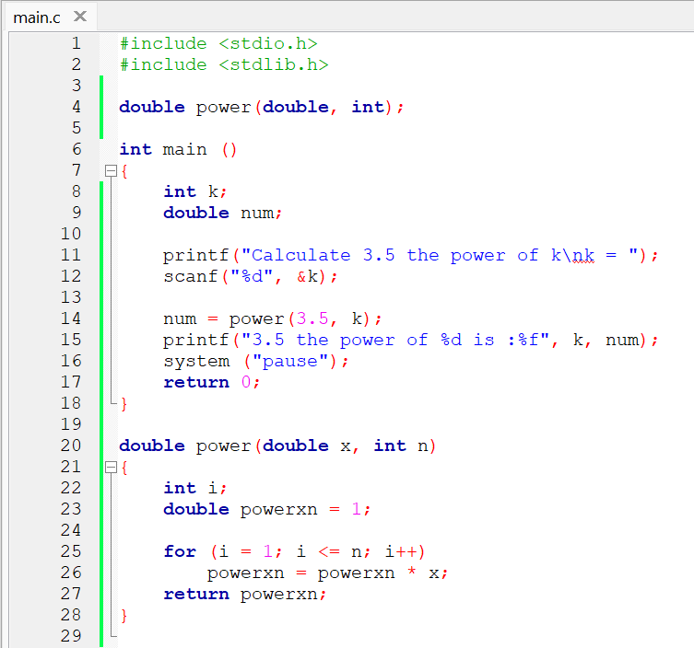

P15

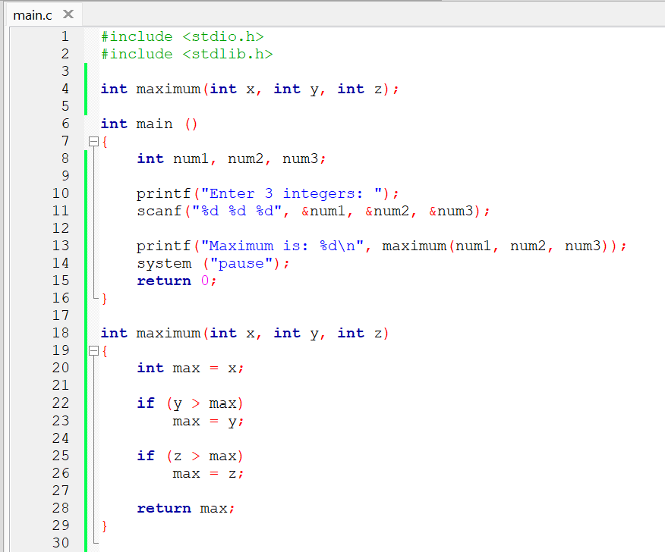

P16

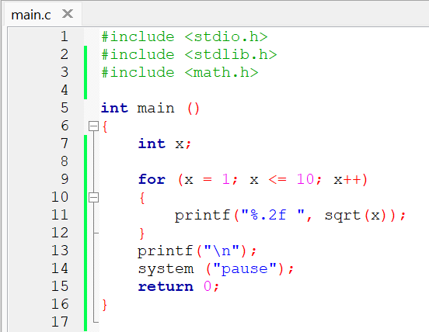

P18

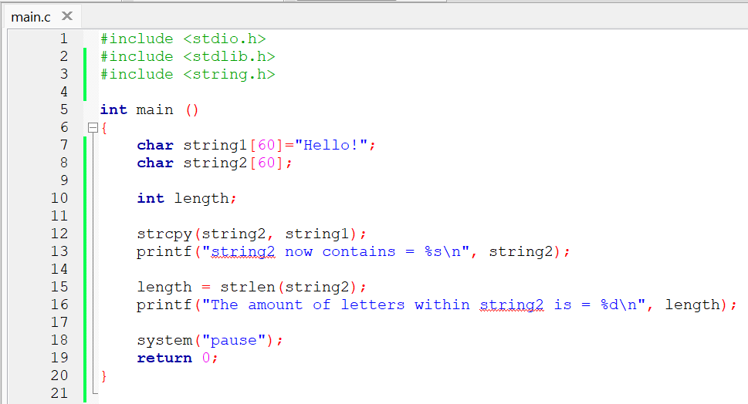

P20

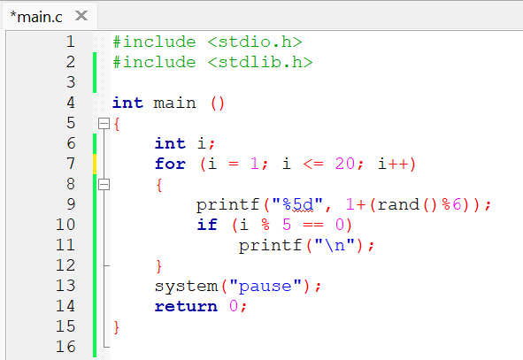

P21

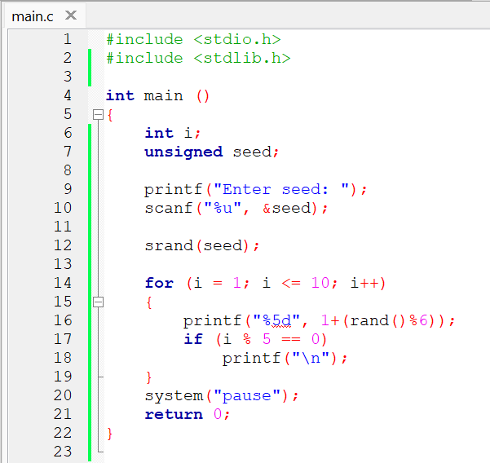

P23

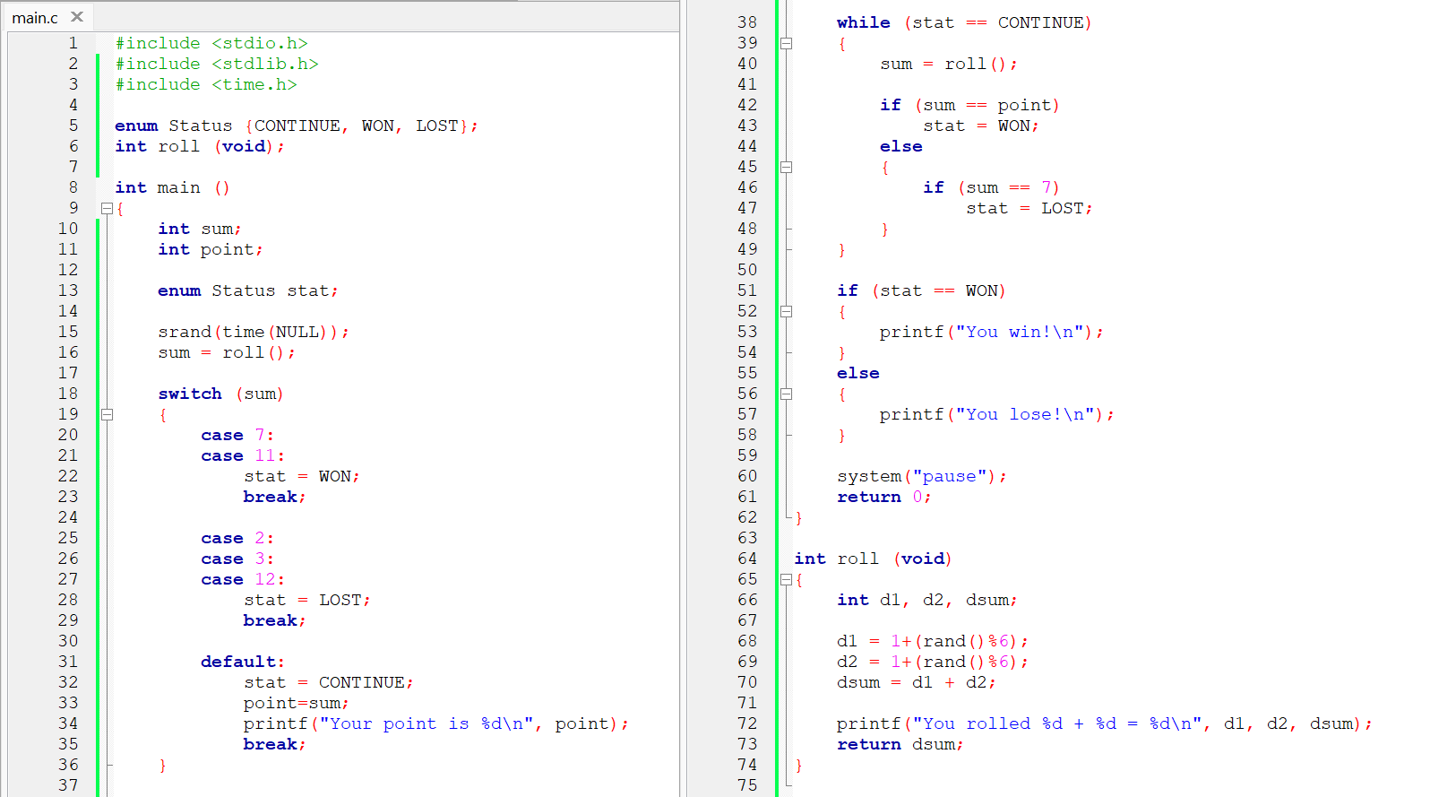

P27

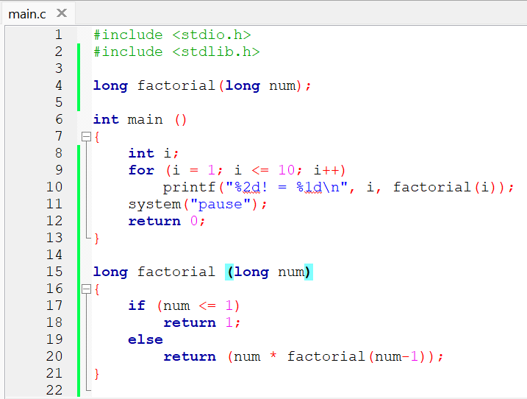

Conclusion:

From doing this homework, I learnt a lot about functions. To create a function, you can add a data value with the format [dataValue functionName (dataValue)]. To use the function, you only need to add the function as a variable, Ex: functionName(dataValue) . There are also premade functions by adding an #include function, such as #include <math.h>, #include <string.h>, and #include <time.h>.

Code : https://github.com/AldrichWijaya/Homework